SEMKUR cell sorting

SEMKUR cell sorting can allow an individual to differentiate cells based on thiol labeling. In this case, our partner shows a shift to a more reduced state as a result of treating Alzheimer’s neuronal cells with a potential new drug.

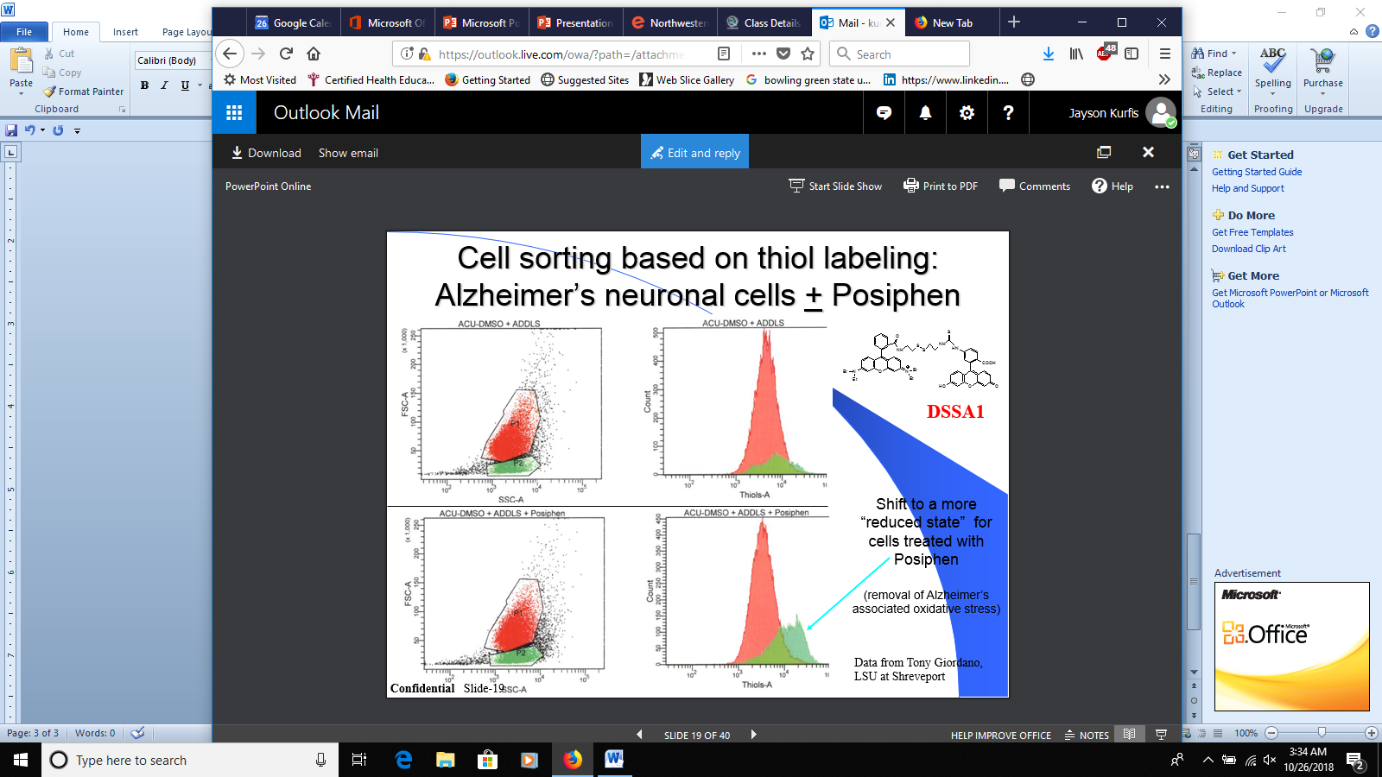

Special note: Would like to remove the drug name from the graphs.